[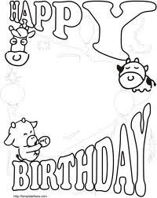](http://www.google.com/imgres?q=funny+birthday+templates&um=1&hl=en&safe=active&sa=X&biw=1024&bih=600&tbm=isch&tbnid=I05QF1KGt0qXlM:&imgrefurl=http://www.fullfreesoftware.com/post/bi/birthday-cards-printable.html&docid=oJt-_xUMVumcgM&imgurl=http://www.fullfreesoftware.com/post/bi/birthday-cards-printable/-...-your-own-birthday-card-that-funny-for-kids-templates-free-printables.jpg&w=532&h=669&ei=VNRYUPbtJIKCyAGxy4DQAQ&zoom=1&iact=hc&vpx=674&vpy=216&dur=3483&hovh=252&hovw=200&tx=99&ty=186&sig=110735643799443925074&page=1&tbnh=122&tbnw=97&start=0&ndsp=18&ved=1t:429,r:10,s:0,i:103)