Name________________________________________
Date_________________________________________
Hour_________
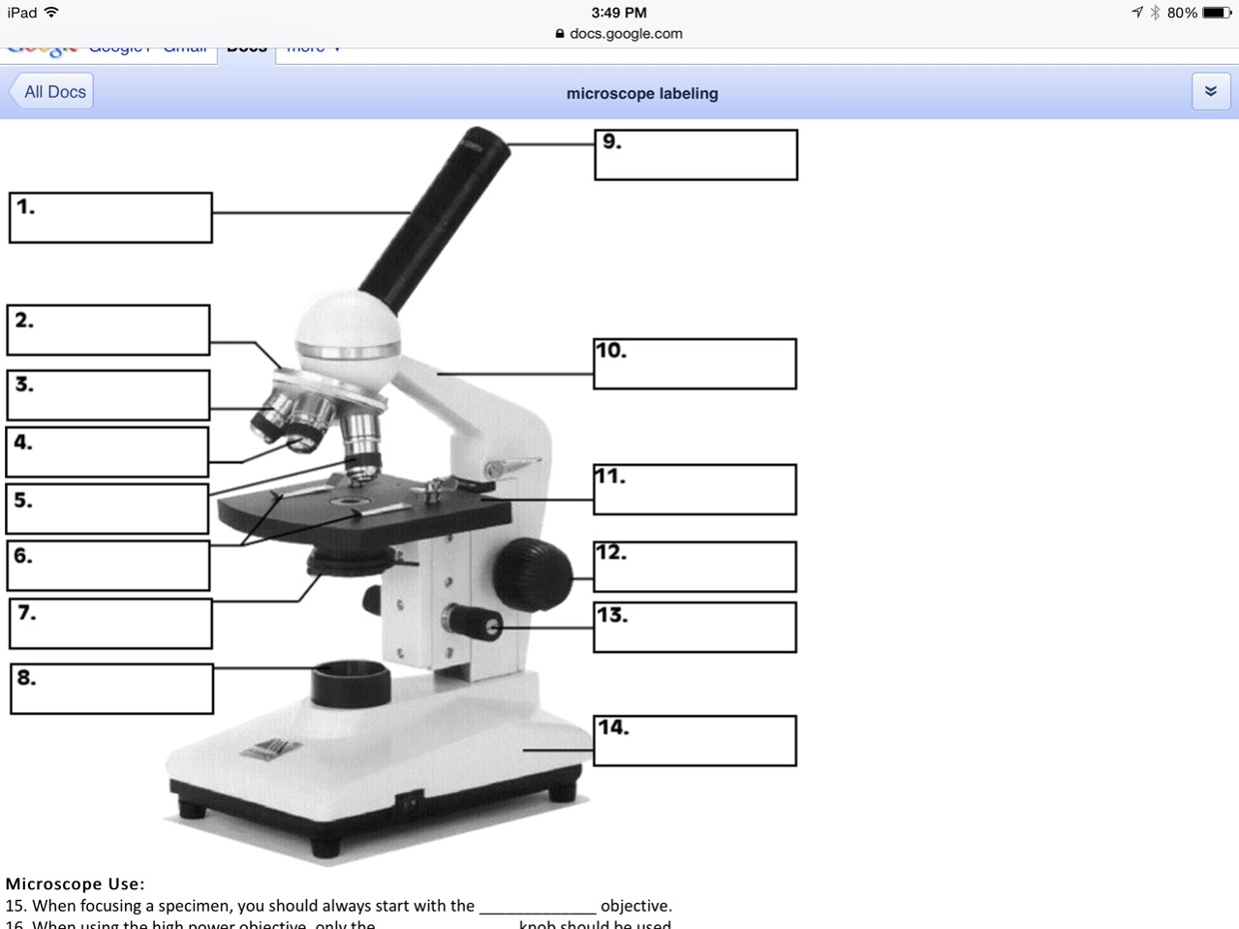
Label the parts of the microscope. Use the word bank.
Arm Diaphragm Objective Lenses
Body Tube Stage Stage Clips
Base Nosepiece Eyepiece (Ocular Lens)
Coarse Adjustment Knob Fine Adjustment Know Light Source

